ALTON PARISH COUNCIL
FOOTPATH CLOSURE NOTICE

Please note that Footpath at the Junction of Alton 45, and the path to The Wheel will be closed until further notice due to a collapsed stile.
The matter has been reported to Stoke City Council. The footpath will remain closed until the stile has been repaired.

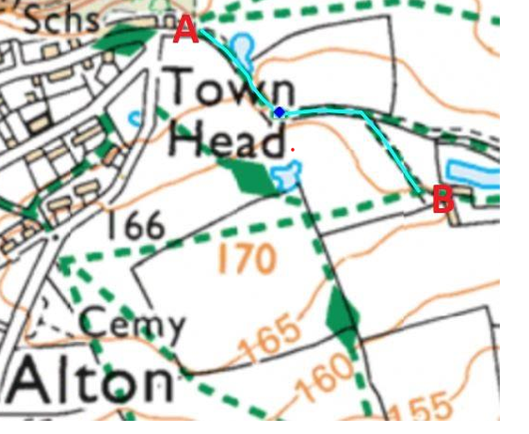
A- B denotes ALTON 45 Footpath

